INTRODUCTION

* 1. **Overview**

**It serves as a self-explanatory image that people can use to connect with your brand. This informs the audience while giving them something to associate your brand and ideas with. Graphics marks have been long used by humans to signify their products, work, and even their bloodline.**

* 1. **Purpose**

**Logos are a point of identification they’re the symbol that customers use to recognize your brand. Ideally, you’ll want people to instantly connect the sight of your logo with the memory of what your company does- and, more importantly, how it makes them feel. Logos are a part of our every day lives. They represent a brand and their story to the world while also influencing our buying decisions, whether we realize it or not.**

1. **Problem Definition & Design Thinking**

**2.1Empathy map**

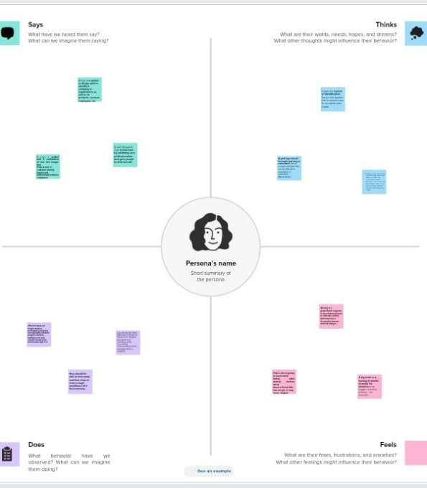

**2.2 Ideation & Brainstorming map**

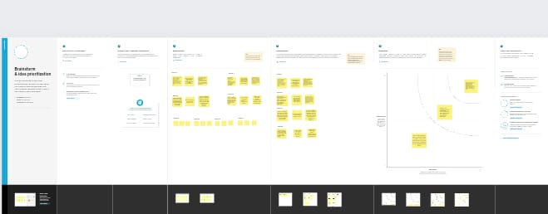

1. **Result**



1. **Advantages & Disadvantages**

**4.1 Advantages**

* **Canva offers a variety of templates and elements**
* **Templates can be altered to be more custom**
* **Canva offers a professional look**

**4.2 Disadvantages**

* **Cannot download the “Raw” file to your computer the free version is limited.**
* **You are unable to move one design to another design.**

**5 Applications**

**I have used mural application and canva application.**

**6 Conclusion**

**We have created logo design with the help of canva.**

**7 Future Scope**

**We were planning to join the logo designing course.**